From Catholic Schools Week Supplement January 23, 2008

Welcoming newcomers: Hispanic outreach program serves needs of families
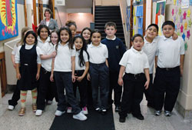
St. Philip Neri School students pose for an informal class picture on their way to lunch on Jan. 10 at the Indianapolis East Deanery grade school. Campus minister Mary McCoy stands in the hallway behind them. This year, 93 percent of St. Philip Neri’s students are Hispanic. Five years ago, that figure was about 70 percent. English as a New Language programs and bilingual teachers are helping tino students and their families acclimate to a new language and culture. (Photo by Mary Ann Wyand)

By Mary Ann Wyand

